SPRINT PLANNING & USER STORY WORKSHOP DOCUMENT
Assessment Tool 2 – Agile Sprint Planning & User Story Workshop

- Project Vision and Stakeholders
  - Project Vision
To build a centralized, real-time emergency response platform that connects affected people, rescue agencies, and resource coordinators during natural disasters. The platform prioritizes urgent incidents, speeds up rescue operations, and improves the use of available resources.

Objectives
Register and locate disaster incidents quickly.
Prioritize emergency requests based on severity and life-threatening risks. Track rescue teams, medical units, vehicles, and relief supplies.
Monitor shelter locations, capacity, and inventory. Provide real-time updates and operational reports.

Stakeholders and Roles

Stakeholder | Role / Responsibility
Affected citizens | Report emergencies and request rescue or shelter.
Emergency dispatch operators | Register and validate incident reports and monitor the dispatch  queue.
Rescue teams / field responders | Attend incidents, receive assignments, and update rescue status.
Disaster response coordinators | Coordinate agencies, prioritize incidents, and allocate resources.
Shelter and logistics managers | Manage shelter capacity, food,  medicines, and relief supplies.

Police, fire, and medical services | Provide emergency, rescue, and medical support.
System administrator | Manage users, access permissions, and system settings.

Epics and User Stories
Epic 1: Incident Reporting and Intelligent Prioritization
US1.1 (5 points): As an affected citizen, I want to submit an SOS report with my GPS location and medical status, so that rescue teams can locate and help me quickly.
US1.2 (8 points): As an emergency dispatch operator, I want the system to prioritize incidents based on life-threatening risks and age-related risk factors, so that the most urgent cases receive help first.

Epic 2: Field Resource and Rescue Team Management
US2.1 (8 points): As a disaster response coordinator, I want to view nearby available rescue teams on an interactive map, so that I can assign a suitable team to high-priority incidents.
US2.2 (3 points): As a field rescue team leader, I want to receive dispatch alerts and update task statuses, so that the control centre has real-time information.

Epic 3: Shelter and Relief Inventory Tracking
US3.1 (5 points): As a shelter manager, I want to update bed availability and food supplies, so that affected people can be directed to shelters with available space.
US3.2 (3 points): As a disaster response coordinator, I want to generate automated response reports, so that agencies can review response times and improve future operations.

Acceptance Criteria (Given–When–Then) US1.1 – SOS Incident Reporting
Given an affected citizen opens the mobile/web interface.

When the citizen submits an SOS report with the situation, number of trapped people, and live location enabled.
Then the system stores the incident, captures GPS coordinates within 10 metres accuracy, creates a unique Incident Ticket ID, and sends the report to the dispatch queue within 3 seconds.

US1.2 – Automated Priority Engine
Given emergency reports are waiting in the queue.
When the system detects high-risk flags such as a medical emergency, rising water, or elderly/children trapped.
Then it marks the incident Priority Level 1 (Critical), moves it to the top of the dispatch list, and displays a red warning.

US2.1 – Interactive Resource Dispatch Map
Given a coordinator is viewing the active operations dashboard. When the coordinator selects a Priority Level 1 incident on the map.
Then the map highlights available rescue teams within 15 km and displays their equipment and estimated arrival time (ETA).

US2.2 – Responder Status Updates
Given a rescue team has received an assignment.
When the team leader changes the task status to En-route, On-site, or Resolved.
Then the updated status is saved and shown to the control centre without requiring a manual refresh.

US3.1 – Shelter Capacity Tracking
Given a shelter manager is signed in.
When the manager updates bed availability or food supply levels.

Then the system saves the updated values and displays the current shelter capacity and inventory to authorized coordinators.

US3.2 – Response Reporting
Given response incident and task data are available.
When a coordinator requests a report for a sprint or disaster.
Then the system generates a report containing incident counts, response times, task statuses, and resource usage.

Product Backlog Prioritization
The MoSCoW method prioritizes work as Must Have, Should Have, Could Have, or Won't Have in the current release.

Priority | Story ID | Backlog Item | Story Points
Must Have | US1.1 | SOS reporting with live GPS | 5
Must Have | US1.2 | Automated incident  prioritization | 8
Must Have | US2.1 | Interactive map and nearest rescue team  selection | 8
Must Have | US2.2 | Responder status updates | 3
Should Have | US3.1 | Shelter capacity and logistics  tracker | 5
Should Have | US3.2 | Automated  response and audit reports | 3
Could Have | US4.1 | Offline SOS messaging through SMS gateway | 8

Won't Have in this release | US5.1 | AI drone aerial  damage assessment | 13

Sprint Backlog and Task Breakdown
Sprint 1 duration: 2 weeks. Selected stories: US1.1, US1.2, US2.1, and US2.2. Total: 24 story points.

Story ID | Task ID | Task Description | Assignee | Hours
US1.1 | T1.1.1 | Create PostgreSQL/PostGIS  incident database schema | DB Engineer | 6
US1.1 | T1.1.2 | Develop incident  submission API and GPS capture | Backend Developer | 8
US1.1 | T1.1.3 | Design mobile-friendly SOS submission interface | Frontend Developer | 6
US1.2 | T1.2.1 | Develop prioritization logic based on severity  rules | Backend Developer | 10
US1.2 | T1.2.2 | Implement real-time  priority queue updates | Backend Developer | 8
US2.1 | T2.1.1 | Integrate an interactive map into the control panel | Frontend Developer | 8
US2.1 | T2.1.2 | Find nearest available rescue teams within a  radius | DB/Backend Developer | 8
US2.2 | T2.2.1 | Build responder  view for task status updates | Frontend Developer | 6
US2.2 | T2.2.2 | Trigger real-time alerts when status changes | Backend Developer | 6

Effort Estimation Using Story Points

Planning Poker with the Fibonacci sequence (1, 2, 3, 5, 8, 13, 21) is used. Estimates consider complexity, safety risk, and technical dependencies.

User Story | Points | Justification
US2.2 – Status updates | 3 | Simple status changes  with basic authorization.
US1.1 – SOS and GPS | 5 | Requires location permission and handling weak network signals.
US1.2 – Priority engine | 8 | Requires multi-factor risk rules and real-time queue updates.
US2.1 – Geospatial map | 8 | Requires map integration, distance queries, and live  markers.

Sprint Goal and Expected Deliverables
  - Sprint Goal
Establish an end-to-end incident management process that lets citizens submit SOS requests with GPS locations, prioritizes life-threatening incidents automatically, and helps dispatchers locate nearby rescue teams on a live map.

Expected Deliverables
SOS Incident Reporting Portal with GPS tagging.
Intelligent Priority Queue that moves critical reports to the top. Dispatcher map showing incident locations and available rescue teams. Field Responder Task View for assignments and status updates.
Quality assurance tests targeting more than 85% code coverage.

Jira Implementation

Figure 1: Jira Project and Scrum Board
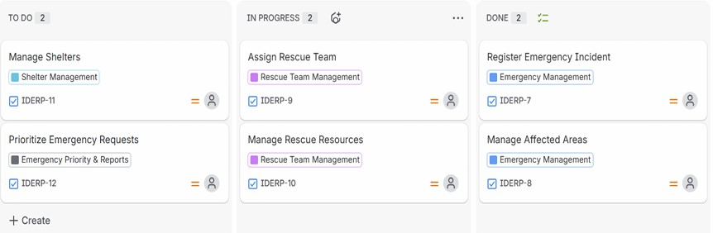

Figure 2: Epics and User Stories
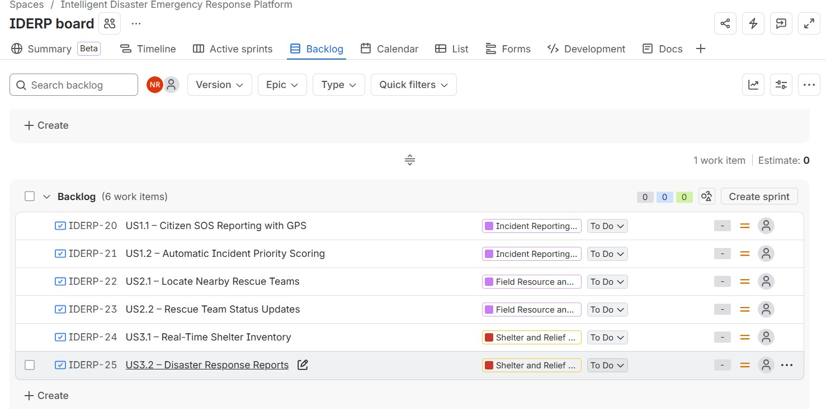

Figure 3: Product Backlog Priorities and Story Points

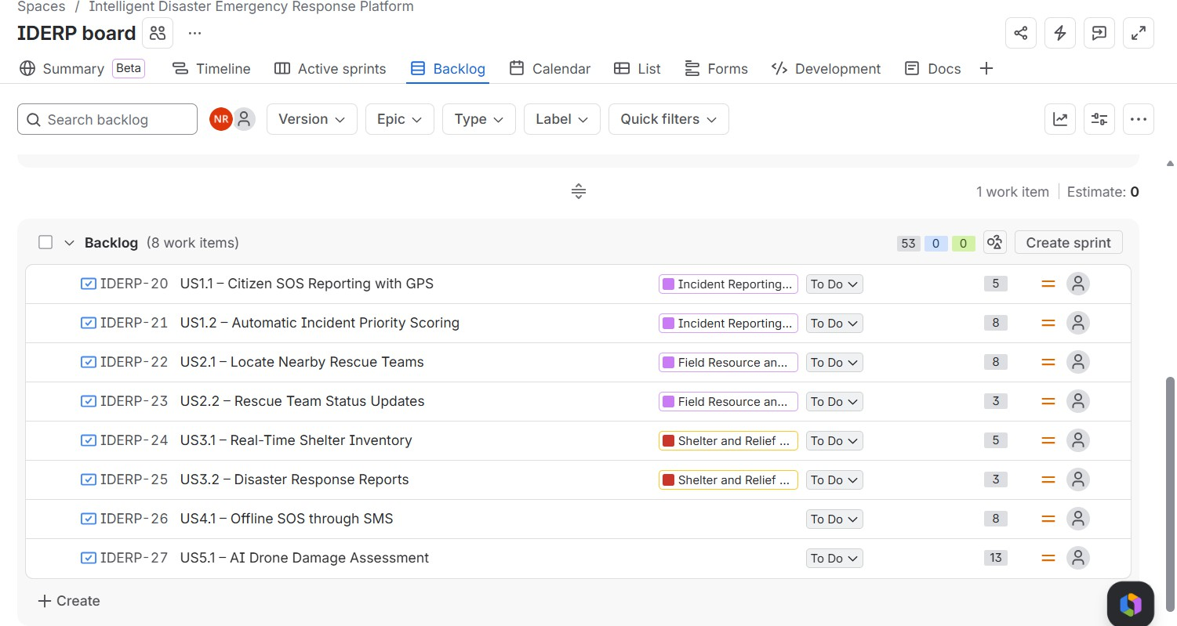

Figure 4: Sprint 1 Planning
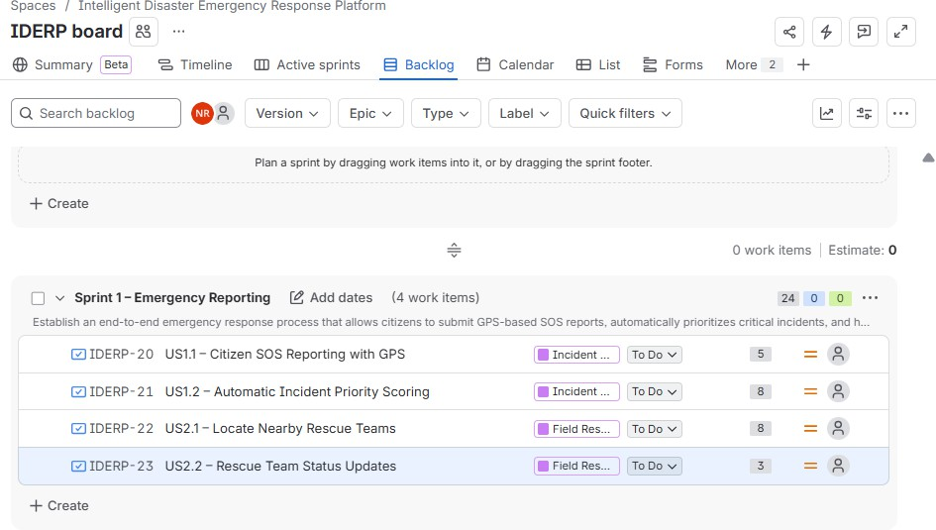

Figure 5: Task Breakdown

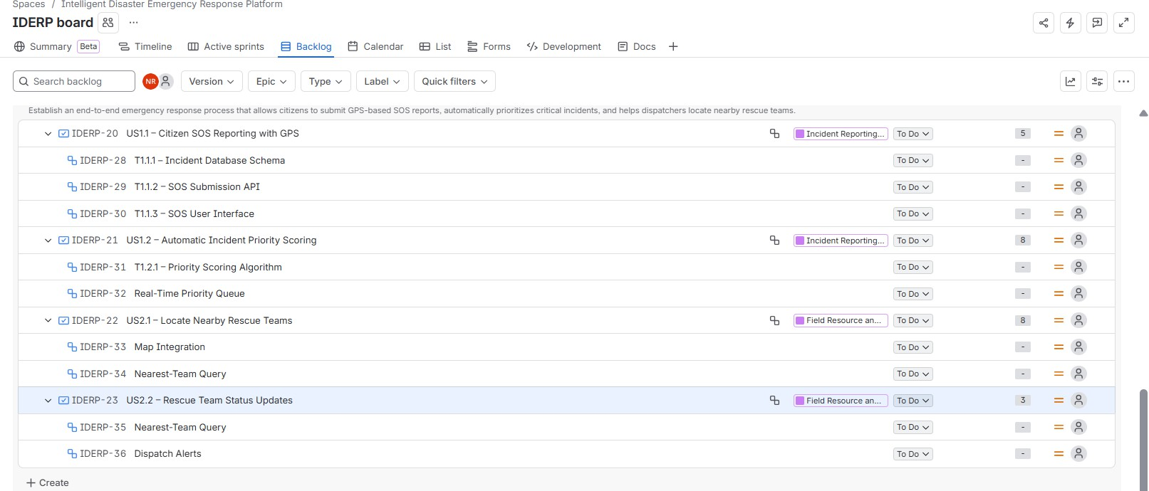

Figure 6: Sprint Board
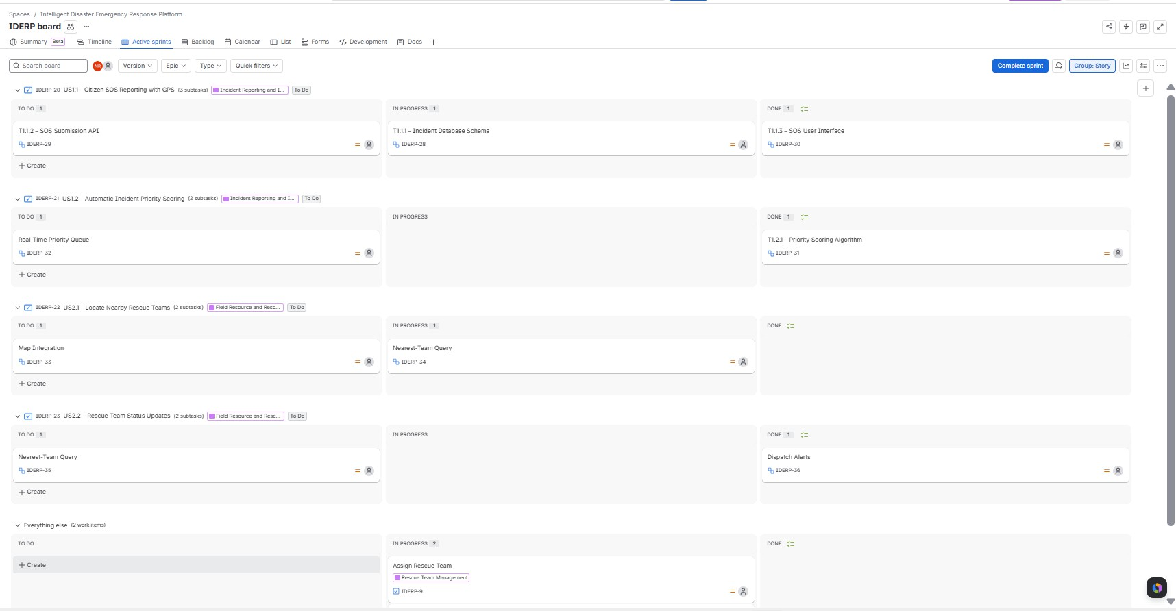

This sprint planning document organizes the disaster response platform into epics, user stories, acceptance criteria, prioritized backlog items, and development tasks. Planning Poker supports effort estimation, while the two-week Sprint 1 focuses on core incident reporting, prioritization, mapping, and responder updates.

